**Initializing the model:**

Keras has 2 ways to define a neural network:

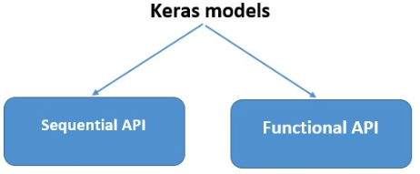

**Sequential:**

* Sequential- A Sequential model is appropriate for **a plain stack of layers**where each layer has**exactly one input tensor and one output tensor.**
* Keras is an API that gets well with neural network models related to artificial intelligence and machine learning so is the keras sequential which deals with ordering or sequencing of layers within a model.
* The core idea of Sequential API is simply arranging the Keras layers in a sequential order and so, it is called Sequential API. Most of the ANN also has layers in sequential order and the data flows from one layer to another layer in the given order until the data finally reaches the output layer.
* In Keras, "dense" usually refers to a single layer, whereas "sequential" usually refers to an entire model, not just one layer. So I'm not sure the comparison between "Dense vs. Sequential" makes sense. Sequential refers to the way you build models in Keras using the sequential api.
* A CNN can be instantiated as a Sequential model because each layer has exactly one input and output and is stacked together to form the entire network.

A Sequential model is **not appropriate** when:

* Your model has multiple inputs or multiple outputs
* Any of your layers has multiple inputs or multiple outputs
* You need to do layer sharing
* You want non-linear topology (e.g. a residual connection, a multi-branch model.

**Function API:**

The Keras functional API provides a more flexible way for defining models.

* It specifically allows you to define multiple input or output models as well as models that share layers. More than that, it allows you to define ad hoc acyclic network graphs.
* Models are defined by creating instances of layers and connecting them directly to each other in pairs, then defining a Model that specifies the layers to act as the input and output to the model.

Function API- the Keras functional API is the way to go for defining complex models, such as multi-output models, directed acyclic graphs, or models with shared layers. This guide assumes that you are already familiar with the Sequential model.

The Keras functional *API* is a way to create models that are more flexible than the [tf.keras.Sequential](https://keras.io/api/models/sequential#sequential-class) API. The functional API can handle models with non-linear topology, shared layers, and even multiple inputs or outputs.

The main idea is that a deep learning model is usually a directed acyclic graph (DAG) of layers. So the functional API is a way to build graphs of layers. The functional API in Keras is an alternate way of creating models that offers a lot more flexibility, including creating more complex models.

Here, Sequential class is used to define linear initializations of network layers which then, collectively, constitute a model. In our example below, we will use the Sequential constructor to create a model, which will then have layers added to it using the add () method.

Now, will initialize our model.